2023

Phan Thao Nhi Nguyen

N11232862

5/5/2023

IFN666 Web APP – Client Side

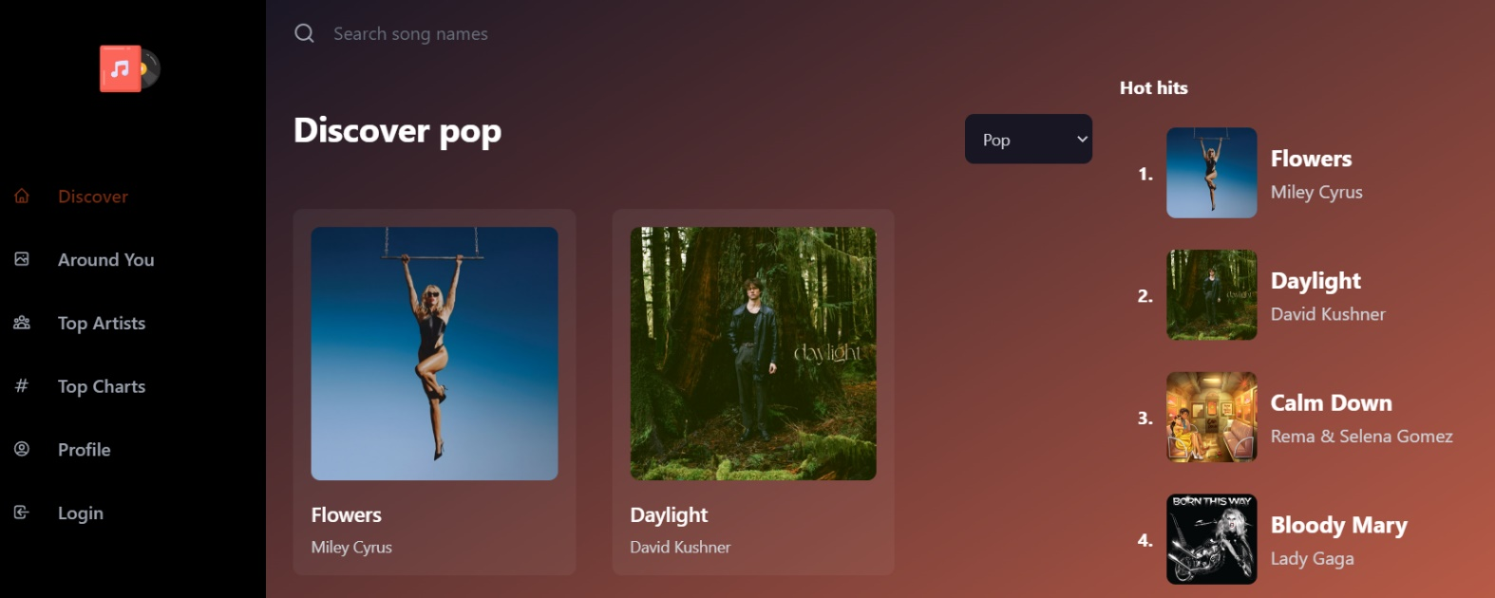

IFN666

Web APP – Client Side

Link to Demo video: https://youtu.be/3NTSb1RC3mI

Contents

Introduction 17

Purpose & description 17

Completeness and Limitations 19

Use of APIs 23

Use of End Points of the chosen API 23

Use of Shazam core API 23

Use of IPData API 27

Use of Reqres API 28

Modules used 29

Application Design 30

Navigation and Layout 30

Technical Description 30

Architecture 31

Test plan 31

Difficulties / Exclusions / unresolved & persistent errors 31

Extensions (Optional) 30

User guide 30

References 32

Appendices 33

Figure

Figure 1: Website home page 4

Figure 2: full trending charts table (sorted, pagination) 5

Figure 3: Trending artist with React Swiper 6

Figure 4: React Router (Discover page) 7

Figure 5: SongCard component 8

Figure 6: Reused SongCard component 8

Figure 7: Shazam core API GET world chart by genre. 10

Figure 8: Shazam core API GET world charts by genre response 10

Figure 9: Shazam core API Get Track details request 11

Figure 10: Shazam Core API GET Track detail response 11

Figure 11: Shazam Core API GET related tracks 12

Figure 12: Shazam Core API GET list of tracks by country code 13

Figure 13: Shazam Core API GET details of artist 13

Figure 14: Shazam Core API GET multi-search by query 14

Figure 15: IPData request, response to get user location 15

Figure 16: Reqres API request, response to get dummy user profile 16

Figure 17: Workflow from Home Page to Around You section 18

Figure 18: Workflow from top music to music detail page 19

Figure 19: Workflow from discover page to top artist page 19

Figure 20: Overall music-app package 20

Figure 21: music app src 21

Figure 22: Home page overall with web browser menu 24

Figure 23: Discover page. 24

Figure 24: Mobile menu 25

Figure 25: Around you Page 25

Figure 26: Trending Artist page 26

Figure 27: Trending charts page. 26

Figure 28: User profile page 27

Figure 29: About us page 27

Figure 30: Contact us Page 28

Figure 31: Sign in modal popup 28

Figure 32: Sign in with required fields. 29

Figure 33: Forgot password page 30

Figure 34: Forgot password required field. 30

Figure 35: Filtered songs my genre. 31

Figure 36: Top charts table with ordered 31

Figure 37: Filtered charts by song name (descending order) 32

Figure 38: Filtered charts by Singer name (ascending order) 32

Figure 39: table with pagination 33

Figure 40: move to next songs by table pagination. 34

Figure 41: Song detail page 35

Figure 42: Suggest related songs 36

Figure 43: Artist detail page 37

Figure 44: Search valid song name 38

Figure 45: Search invalid song name. 38

Figure 46: Search valid artist name 39

Figure 47: Search invalid artist name 39

Figure 48: Error page 40

## Introduction

### Purpose & description

Music is a sort of art that allows us to explore the world around us. It is commonly used to share emotions, tell stories, and bring people together. With my Musique music app's access to top international charts, top playlists, and music from all around the world, it's never been simpler for listeners to discover new musical genres or revisit old favorites. Music has always been an important element of our culture; now with technology, we have even more ways to appreciate its beauty!

Musique is a modern-looking software that gives users access to music from multiple platforms while also giving an entertaining and user-friendly experience regardless of the device they use. We think that by making it easy to locate and enjoy browsing trending music throughout the world, this sort of application will assist promote interaction and develop greater connections between artists and their fans.

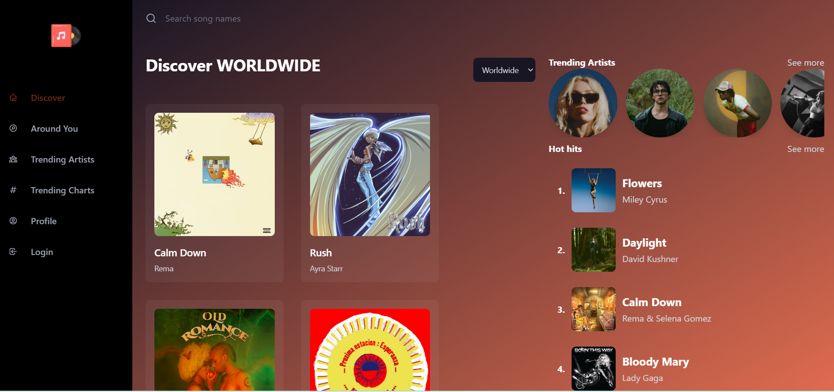

Figure : Website home page

We believe that presenting a sorted, responsive, and paginated table may significantly enhance an online application's user experience (UX) and user interface (UI). Our top charts table may considerably improve a web application's usability and accessibility. It can help users identify the information they want, read, and interact with the table on any device, and digest and analyze massive volumes of data. These characteristics are critical for generating a great user experience and improving a web application's overall UX/UI.

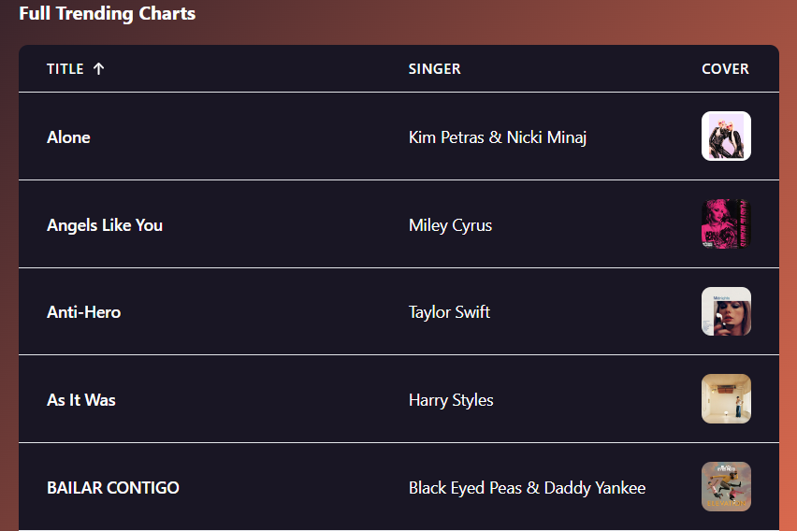

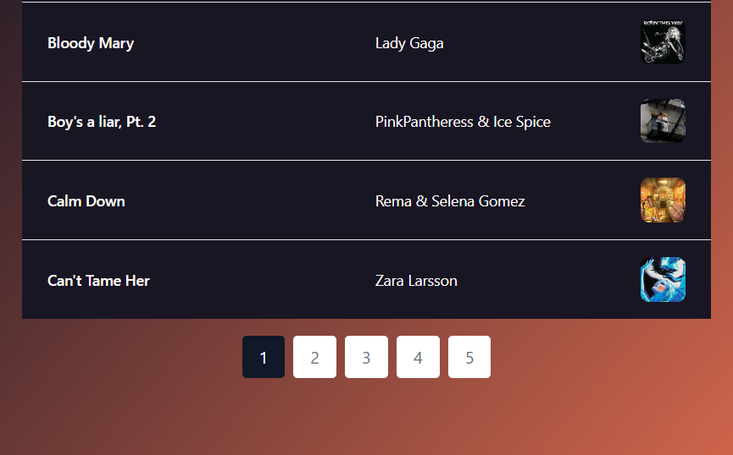

Figure : full trending charts table (sorted, pagination)

Furthermore, we use the React Router Dom module, which is the most popular in React JS. Developers benefit from client-side routing, declarative routing, nested routes, dynamic routing, and browser compatibility with React Router. These capabilities make it easier to create advanced and responsive online apps, as well as improve the overall user experience.

To create a modern-looking user interface, we use the React JS swiper module. The ReactJS Swiper module is responsive, which means it responds to changing screen sizes and resolutions. This makes it simple to design a slider that looks good on both desktop and mobile platforms.

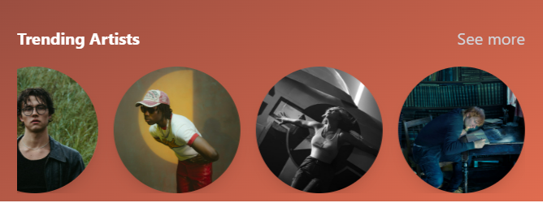

Figure : Trending artist with React Swiper

### Completeness and Limitations

*What works?*

All main features that need for a searching music app including:

_ Display top tracks around the world.

_ Display top artists.

_ Discover music by genre.

_ Search for a song name.

_ Display artist information.

_ Display song details: title, singer, lyrics.

_ Login for registered user, recovery forgot password.

_ Get user profile.

_ We have a table to display a large list of famous songs with order and pagination.

_ We have a chart to display the top streamline trending char.

*What can be implemented in the future?*

We have limited timing to complete this assignment, so we only implemented important features for this app. We have list of could do features that can be implemented to improve the app:

_ User can play songs in the app.

_ User can like their songs, and those will save into user profile as their favorite playlists.

_ User can share songs by share music link with their friends.

_ User profile with their favorite songs, album, artist.

_ User can create their personal playlist.

_ Get streamline music data from app database (currently we are using faking streamline data).

Some features we don’t implement in this current app. In this app, we don’t store user profile in our database, so the user profile is the random profile that we retrieve from user profile free API.

*Reusable components.*

Explanation about how the workflow from Menu selection, route pages, and reused component that we will highlight below this section.

*Feature: discover music by genres.*

Users can explore a list of songs by genre selection. In this feature we SongCard component as reused component between many features. From that, we just need to develop a beautiful component and reuse it for the other pages. Here is some of the screenshot to explain about this feature with using React Router and reusing a component.

Line 39: We use React Route to navigate to Discover feature.

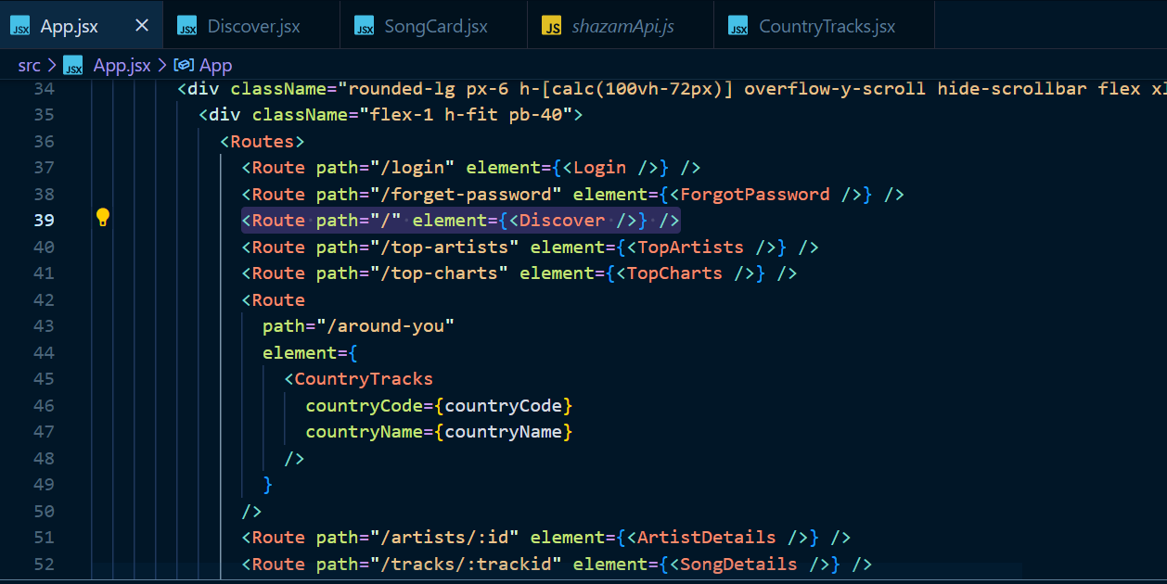

Figure : React Router (Discover page)

Line 51: We reuse SongCard component to display all of songs by user selection music genre.

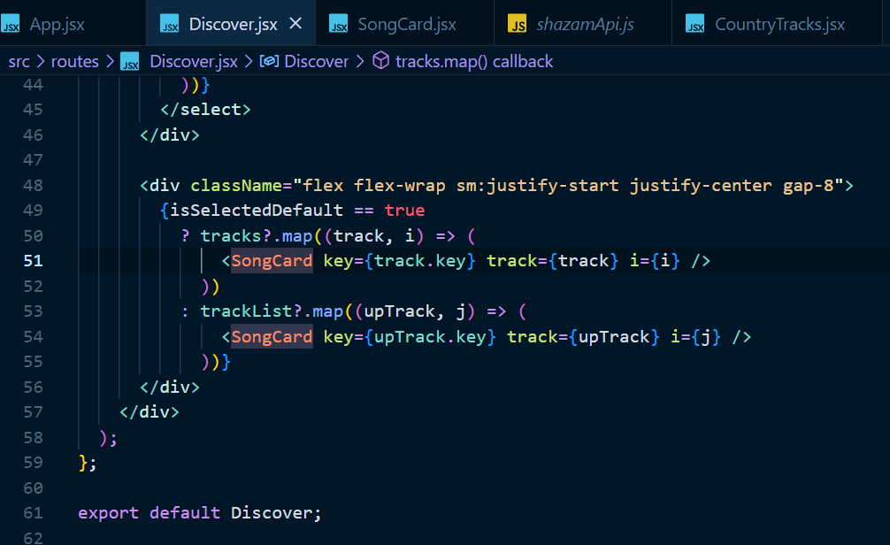

Figure : SongCard component

A reusable SongCard component

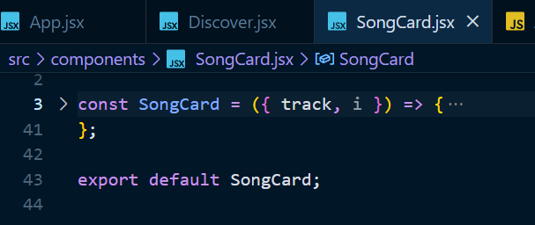

Figure : Reused SongCard component

Here is the other reused SongCard component feature. That mean this SongCard component is flexible enough to reuse (line 21)

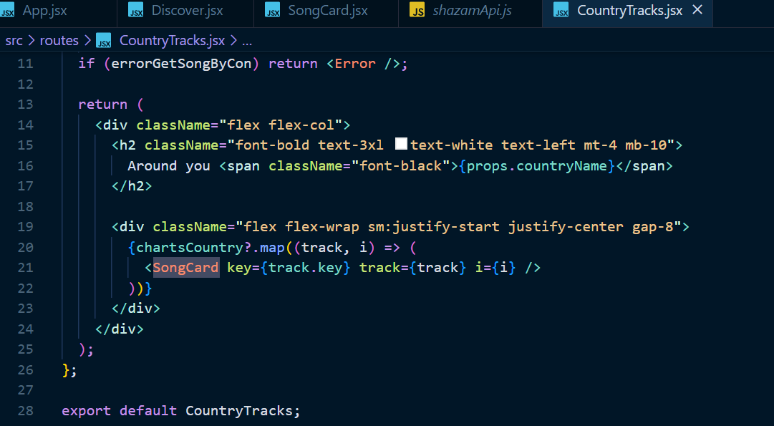

## Use of APIs

_ Shazam Core: music API

_ IPData: user location

_ Reqres API: fake user data

## Use of End Points of the chosen API

## Use of Shazam core API

***Please not that we paid for this API to get 10,000 request per month. So, if you have any issue to connect with this API while doing marking. Please contact us, so we can extend the request for you.

<https://rapidapi.com/tipsters/api/shazam-core/details>

We use this API as our website main API to get list of top music by genre. Shazam Core API defines the song by uploading the file. Get detailed data on songs and artists. Ready-made lists of charts in cities and countries. Covers, video clips, and lyrics. (Shazam Core API)

Users can select genre music and we will pass it as argument to get list of tracks which is related to user selection. This endpoint will return list of tracks which contain much information of songs (title, singer, cover image)

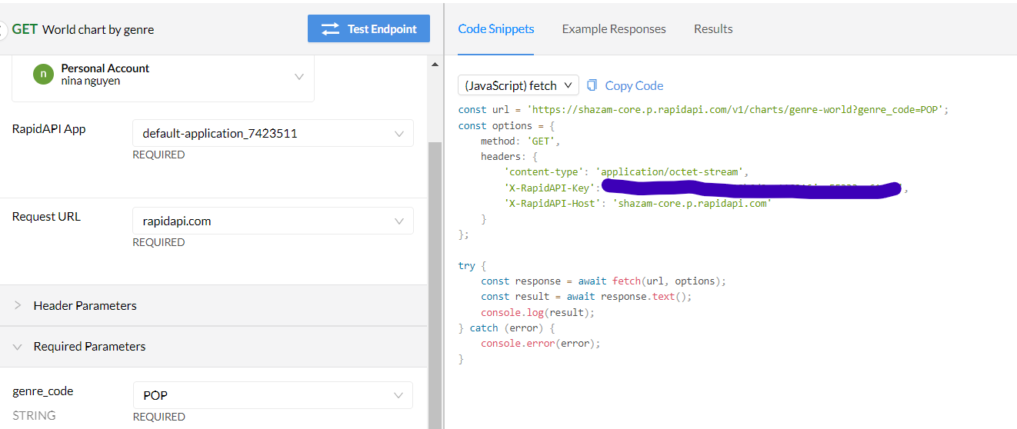

Figure : Shazam core API GET world chart by genre.

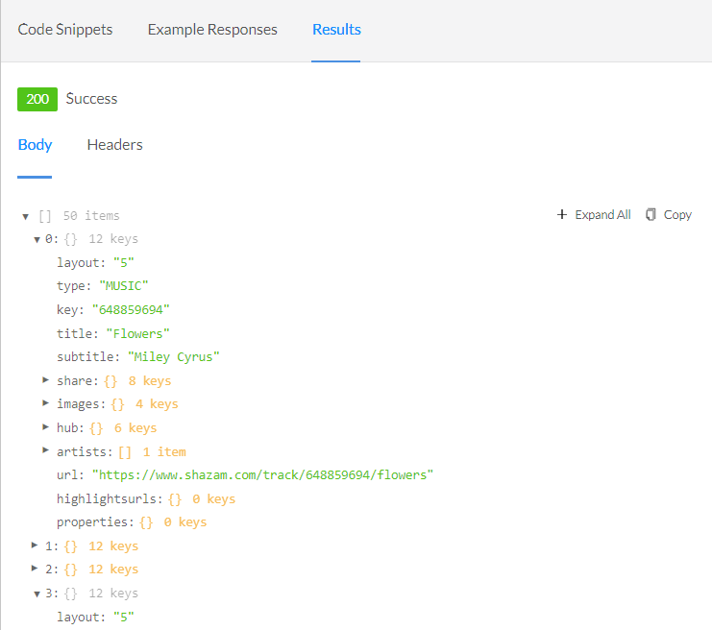

Figure : Shazam core API GET world charts by genre response.

*Get Track Detail by their ID:*

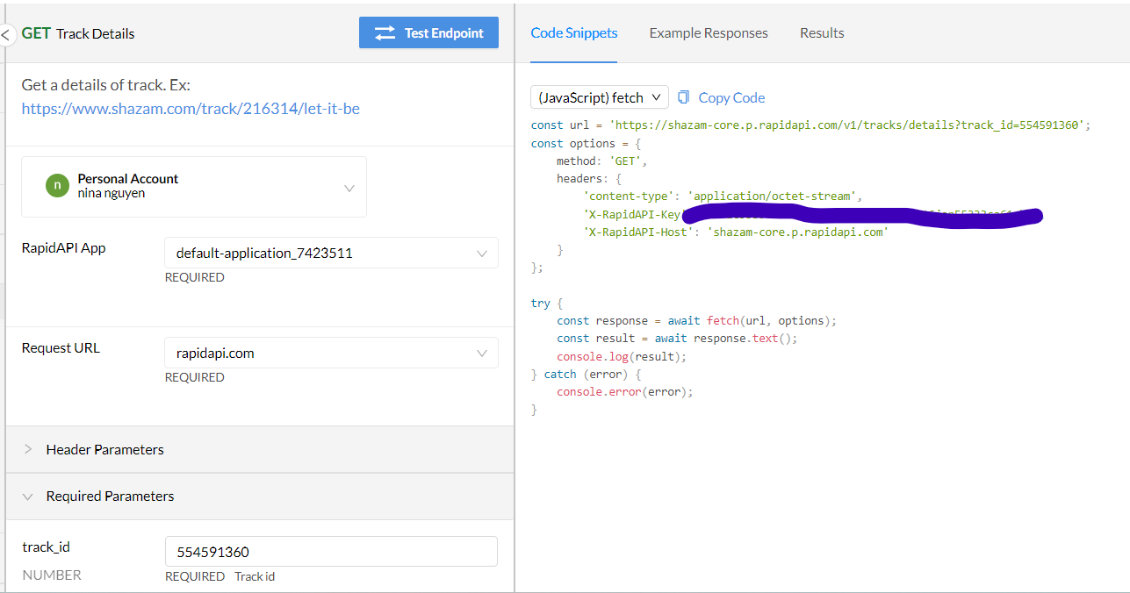

Figure : Shazam core API Get Track details request.

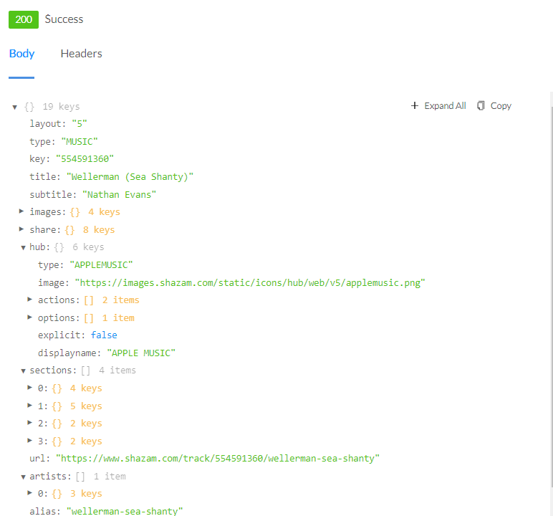

Figure : Shazam Core API GET Track detail response.

Response will contain the track detail (song name, artist, lyrics…)

*Get list of related track by track ID*

We use this API to get related songs when user chooses a song.

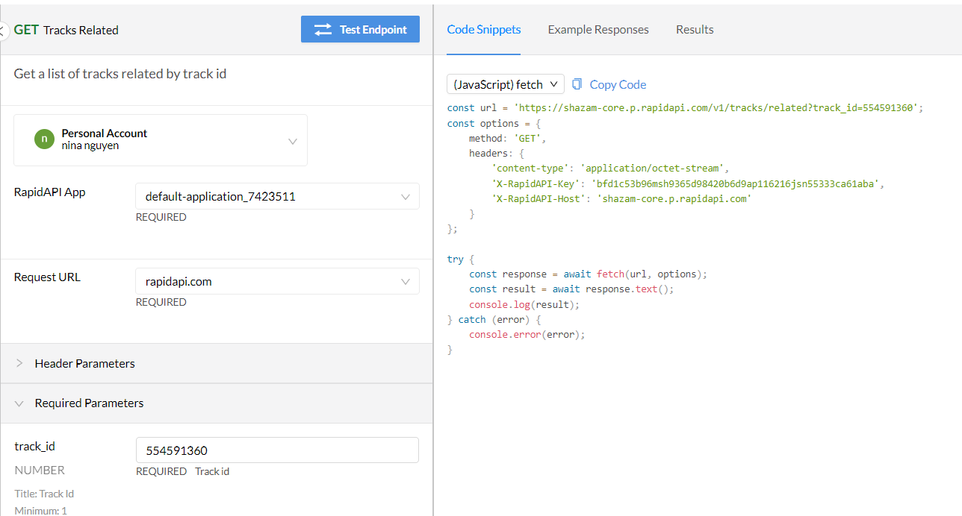

Figure : Shazam Core API GET related tracks

*Get a list of tracks by country code.*

From this API, we can display top songs that are user location.

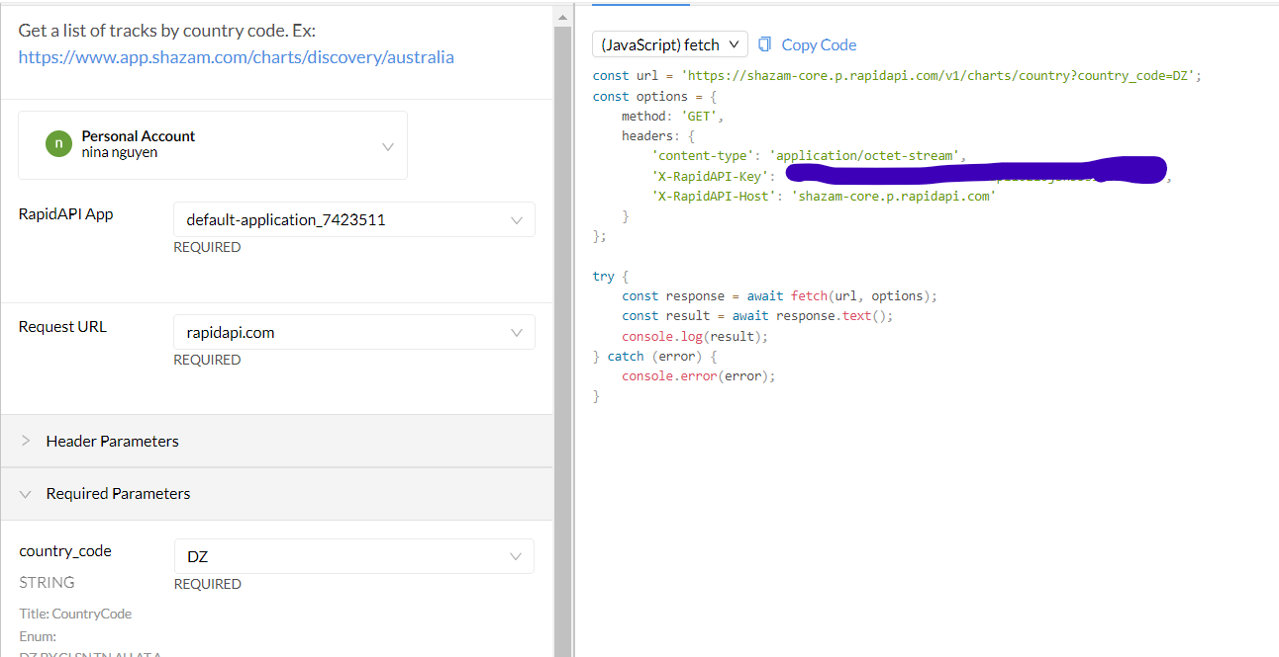

Figure : Shazam Core API GET list of tracks by country code.

*Get artist detail by their ID.*

User can see their favorite artist detail (name, image….)

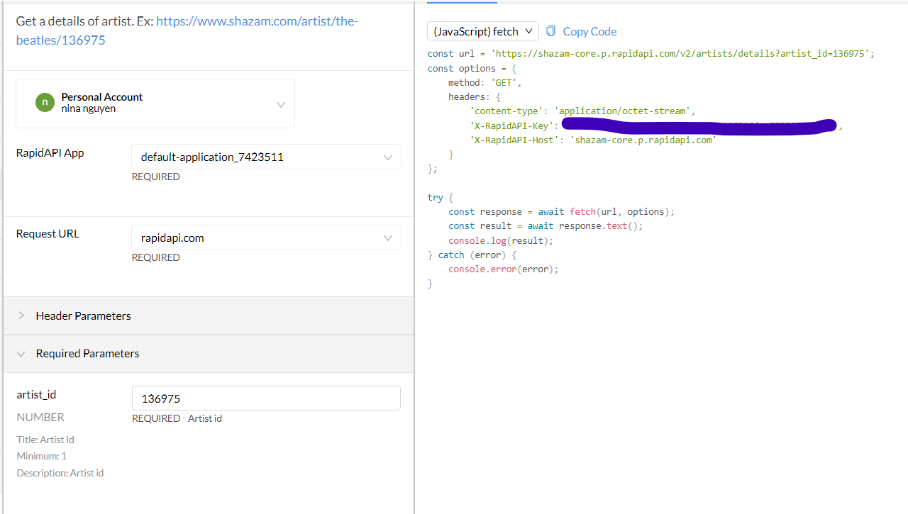

Figure : Shazam Core API GET details of artist

*Multi-search by query (song, artist)*

Users can search songs by name or artist name.

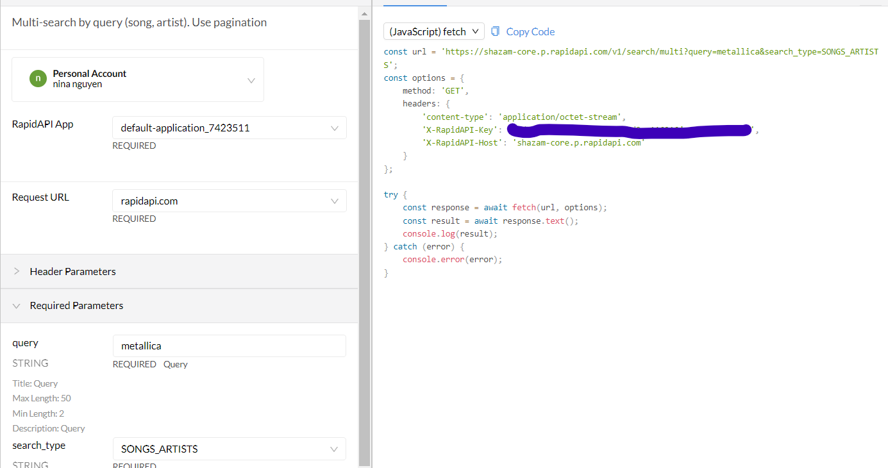

Figure : Shazam Core API GET multi-search by query.

## Use of IPData API

Get user current location (country) by IPData (https://docs.ipdata.co/docs/getting-started)

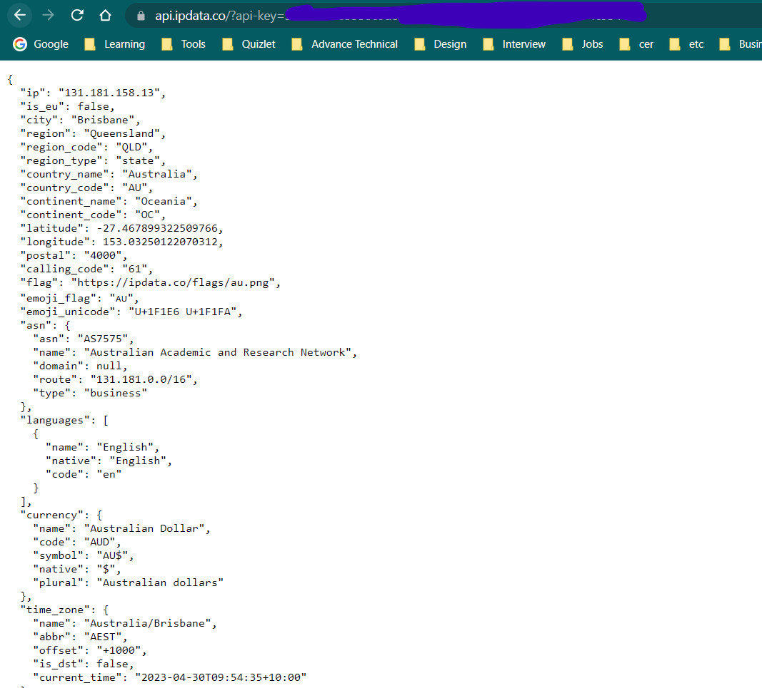

Figure : IPData request, response to get user location.

## Use of Reqres API

Get dummy User profile by Reqres API (https://reqres.in/api)

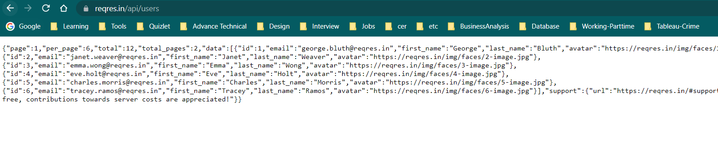

Figure : Reqres API request, response to get dummy user profile.

### Modules used

This is just a list of the external modules that you have used. You need not specify core React modules. In each case, ***we want the name, a brief description, and a link to the docs at npm or github or wherever.*** The first one is ag-grid-react as most people will be using this. Just copy that style and add more as necessary.

#### React Router, React Router Dom

The react-router package is the heart of React Router and provides all the core functionality for both react-router-dom and react-router-native (NPM).

<https://github.com/remix-run/react-router>

React Router Dom contains binding for using React Router.

<https://github.com/remix-run/react-router/tree/main/packages/react-router-dom>

#### React Table

A well-defined wrapper for a table. We can easily modify table header, body, footer.

<https://www.npmjs.com/package/react-table>

#### React Swiper

Swiper is a modern look for touch slider features with applicable for multiple devices (web, mobile…). Swiper - is the free and most modern mobile touch slider with hardware accelerated transitions and amazing native behavior. It is intended to be used in mobile websites, mobile web apps, and mobile native/hybrid apps (NPM).

<https://www.npmjs.com/package/swiper>

#### React Chart 2

React Chart 2 is a popular React library for creating various types of charts and graphs with customizable options and features.

<https://www.npmjs.com/package/react-chartjs-2>

#### React Icon

React icon gives us ability to include modern icon into our project

<https://www.npmjs.com/package/react-icons>

## Application Design

## Navigation and Layout

There are various stages to consider while developing an application layout. As a designer, we want to create a music app that allows users to browse popular songs, artists, and song titles. First, the designer must understand the application's purpose and devise a strategy to help them achieve their goal. This entails investigating similar apps and comprehending user requirements to build a design that is both practical and visually attractive.

The next step is to select an acceptable development platform, as well as any tools or frameworks required for implementation. As part of the assignment, this application must be usable on a web browser and on a mobile device. As a result, we must create responsive layouts for applications. We should also select the elements, such as navigation menus, search tools, or data entry forms, we want to utilize in the design. Furthermore, consider how users will interact with these components when using your app to ensure usability across all devices and platforms. We have a list of features that need to be completed in this project after some consideration.

_ Home landing page (Home Page).

_ Discover music with genres (Discover Page).

_ Discover music in user’s country (Around You Page).

_ Explore trending songs, artists (Songs/Artists Page).

_ Display song’s detail information (genre, singer, lyrics…) (Songs Details Page).

_ Display artist information (Artists Details Page).

_ Display related songs with user chosen song (Songs Details Page).

_ Login, Forget passwords recovery, display user profile (Login/ForgetPassword/Profile Page).

_ Search song by Search Page (Search result page).

_ Provide application meaning, purpose, and mission (About Us Page).

_ Provide owner application contact details including email, phone number (Contact Us Page).

The menu items will have Discover, Around You, Trending Songs, Trending Artists, Profile, Login Page. We want to use Tailwind CSS in this project to explore a new CSS framework with a modern look. When a user selects an item from the menu sidebar, the application will immediately route the page to the chosen page. We also focus on layout design, color, and logo to make this application more appealing.

Our music app with a menu of Discover, Around you, Top charts, Top Artist, and Profile offers a variety of ways for users to explore and interact with the app's content. The Discover section is where users can discover new music around the world or music by user selection genre. We have music genre drop down box selection that helps user can select their music genre. “Around you” section allows users to explore music that's popular in their local area. The Top charts section displays the most popular songs and albums globally or by region, and Top Artist allows users to discover popular and emerging artists. Each of these menu options link to detailed pages, which offer more information and options for the user. For example, clicking on a specific artist in the Discover section will lead to a page displaying the artist's information, including their image, music genre. Similarly, the Top charts section will display the top chart around the world, and the Top Artist section shows leading artist. The Profile section allows users to their account, profile (name, email). When user wants to see the song detail, the Router will link to song detail which includes song name, artist, genre, lyrics, and related songs.

Here is the flow when user choose Around You section and it will route to Around you page (React Route) to help them explore music that's popular in their local area.

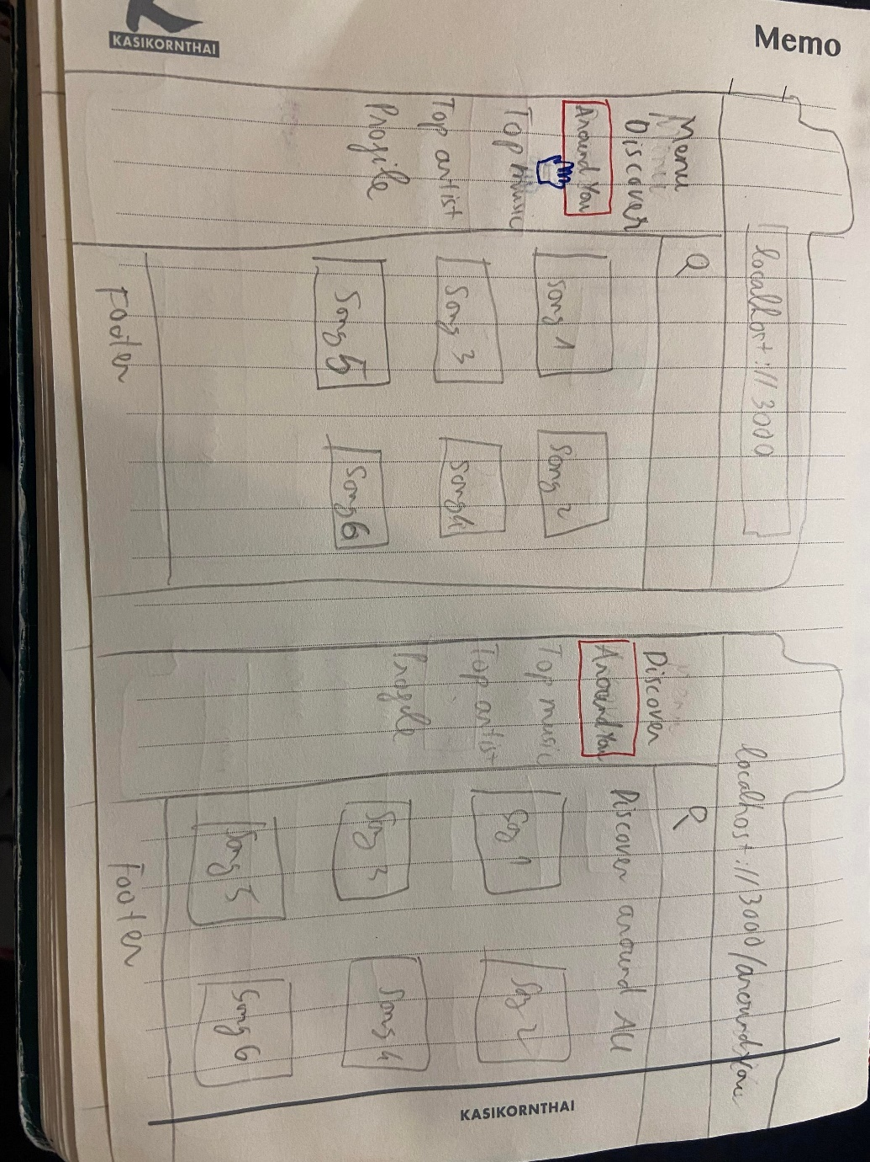

Figure : Workflow from Home Page to Around You section

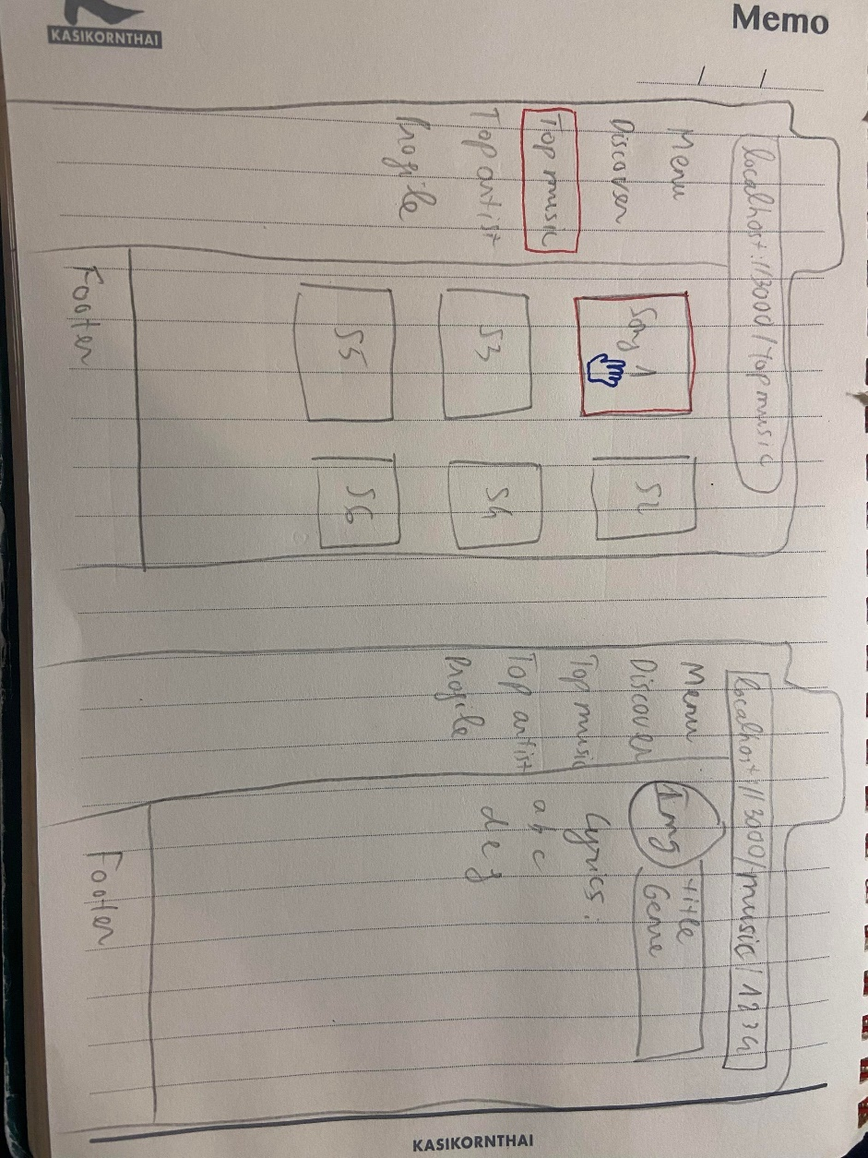

Figure : Workflow from top music to music detail page

When user click to song, the Router will direct to the chart detail by the song ID from that user can see the song detail which includes song title, artist, genre, lyrics, and related songs.

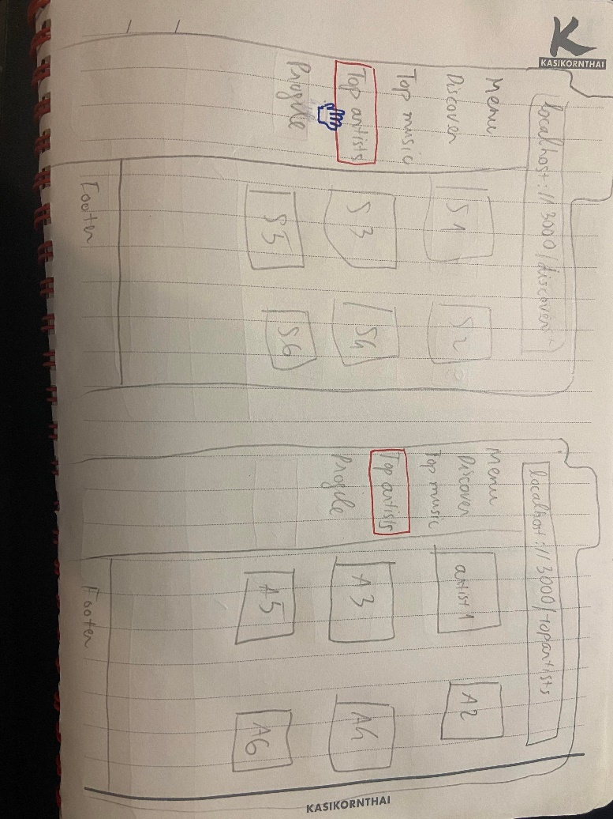

Figure : Workflow from discover page to top artist page

In addition, when user clicks at Top Artist section on Menu. The list of emerging artists will show for customer. From that user can choose and see the artist’s detail information.

A music genre advanced dropdown search may considerably improve the usability of a music app. Users can save time and effort when exploring the app if they have quick and simple access to their favorite music. This may be accomplished by including search choices in the search field such as album name, music genres, and playlist. User profiles may be utilized in the future to save favorite songs, albums, and playlists. Users will be able to simply access their favorite songs and build personalized playlists using this functionality.

Furthermore, implementing filters in the list of charts with many popular songs can help to improve the app's usability. Filters make it easier for consumers to sort and filter popular tracks depending on their preferences, making it easier to find new music. Following friends or other users to find new music and exchange playlists can also be included in the app.

Each of these aspects has the potential to give consumers a unique and personalized experience based on their choices. Users are more likely to interact with and enjoy their listening experience if the music app's usability is constantly improved.

## Technical Description

### Architecture

The overall architecture of this application is including public source:

* public: This folder includes static files that will be delivered by the web server, such as the index.html file, which contains the root element for your React app, as well as other assets such as photos, fonts, and manifest files.
* src: This folder contains the main source code of the application (App.jsx, index.css, index.jsx)

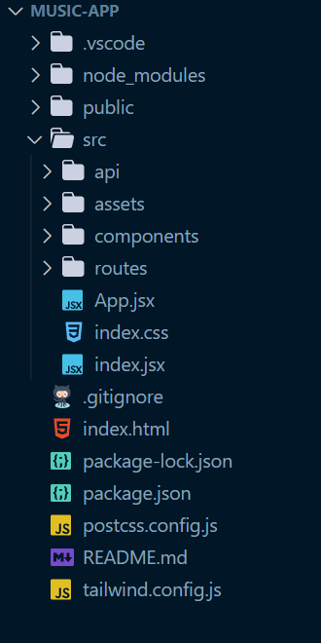

Figure : Overall music-app package

* src/api: This folder contains modules for making HTTP requests to external APIs.
* src/assets: This folder contains constant files (some fixed parameter that need to use in the application), logo, images…)
* src/components: This section offers reusable components for usage across in this application. These components should be stateless and focused to a particular task.
* src/routes: This folder contains the route definitions for your application. Those routes are created and mapped to React components with the support of a tool called React Router.

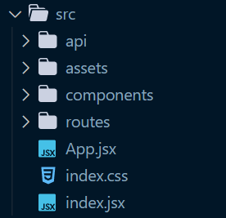

Figure : music app src

We will have the ability to quickly isolate and debug errors, add new features, and cooperate with other developers on our application if we organize our code into different packages. Furthermore, it can help to make our codebase more modular and easier to maintain over time.

The import/export declarations let the various packages communicate with one another. For example, if a component wants to use an API module to send a request to the server, it will use an import statement to import the module from the API directory. Similarly, if the route page wants to use a component in another component, it will use an import statement to import the component.

Overall, separating the application into folders and files increases its maintainability, readability, and reusability. It also makes it easy to find and troubleshoot specific functions.

### Test plan

We do unit test when we did the development process. We also have manual testing to make sure the web pages work as expected. We have table below to show about our testing, expected outcome, result and screen shots.

Our tests include

* Positive outcome cases
* Negative outcome cases (error scenarios)
* edge cases

|  |  |  |  |
| --- | --- | --- | --- |
| **Task** | **Expected Outcome** | **Result** | **Screenshot(s)** |
| **Checking home page** | | | |
| Home page shows on http://localhost:3000/ | Home page displayed Hot hits, top artist sections and list of songs. The page shown Menu web browser. | PASS | Figure 24 |
| Home page shows on with mobile <http://localhost:3000/> | Menu burger icon displayed with full of menu section | PASS | Figure 26 |
| Trending Artist with Swiper, and top 5 Hot hits | Always displayed in the right section | PASS | Figure 25 |
| Check page title is “Discover” | Page title is “Discover” | PASS | Figure 25 |
| Check page title is “Around You” | Page title is “Around You” with user country (Australia) | PASS | Figure 27 |
| Check page title is “Trending Artist” | Page title is “Discover Trending Artists” with list of more artists | PASS | Figure 28 |
| Check page title is “Trending Charts” | Page title is “Discover Trending Charts” with list of more charts | PASS | Figure 29 |
| Check page title is “User profile” | Page title is “User profile” user information | PASS | Figure 30 |
| Check page “About us” | Page title is “About Us” with application mission | PASS | Figure 31 |
| Check page “Contact us” | Page title is “Contact Us” with contact information | PASS | Figure 32 |
| Check Login Page pop up model | Login modal popup with email, password input form to login. | PASS | Figure 33 |
| Check can’t login without required fields (email, password) | Can’t login without entering required fields | PASS | Figure 34 |
| Check Forgot password page title is “Forgot password” | Forgot password page displayed with required email field to recover password | PASS | Figure 35, Figure 36 |
| Check dropdown menu filters by dropdown item selected | Songs filtered by selected genre | PASS | Figure 37 |
| Check full trending charts table by selecting See more option in Hot hits | Table showed up with list of trending songs | PASS | Figure 38 |
| Check charts table pagination (10 charts each page) | Table showed up with page number, and correct number of items each page | PASS | Figure 41 |
| Check filter music by title | Music filtered by name with ascending or descending order | PASS | Figure 39 |
| Check filter music by singer name | Music filtered by singer name with ascending or descending order | PASS | Figure 40 |
| Check pagination | List of next 10 charts showed up in table | PASS | Figure 41 |
| Check collaboration between filter and pagination | Music listed with correct filter and pagination | PASS | Figure 41, Figure 42 |
| Check streamline chart title | Chart showed with name “Top Trending Streamline data” | PASS | Figure 54 |
| Check song detail | Song detail showed up with song title, singer, cover image, lyrics | PASS | Figure 43 |
| Check related songs | Page showed list of related songs when user chose a song | PASS | Figure 44 |
| Check artist detail | Artist detail showed up with name, image, their music genre | PASS | Figure 45 |
| Search “valid” song | Searching detail page showed the searching song name and list of potential songs | PASS | Figure 46 |
| Search “invalid” song | Did not show list of songs and showed “We can’t find your searching info” | PASS | Figure 47 |
| Search “valid” singer | Searching detail page showed the searching singer name and list of potential songs | PASS | Figure 48 |
| Search “invalid” singer | Did not show list of singer’s songs and showed “We can’t find your searching info” | PASS | Figure 49 |
| Check error page by turn of the connection with API | Page title showed error | PASS | Figure 50 |
| **Checking the detailed song/singer information** | | | |
| Detailed track details shown at http://localhost:3000/tracks/{trackId} | Detailed song was shown. | PASS | Figure 43 |
| Detailed artist details shown at  http://localhost:3000/artists/{artistId} | Detailed artist was shown. | PASS | Figure 45 |

Difficulties / Exclusions / unresolved & persistent errors /

*1st difficulty that we tackled:*

When we developed this application, we faced some issues that blocked our workload for a while. First, we can’t use <Link to=…/> as redirect to other page in Search component because we used form onSubmit function to handle for searching. After researching, we come up with using useNavigate hook in react-router-dom. From that we can navigate pages with route in our application.

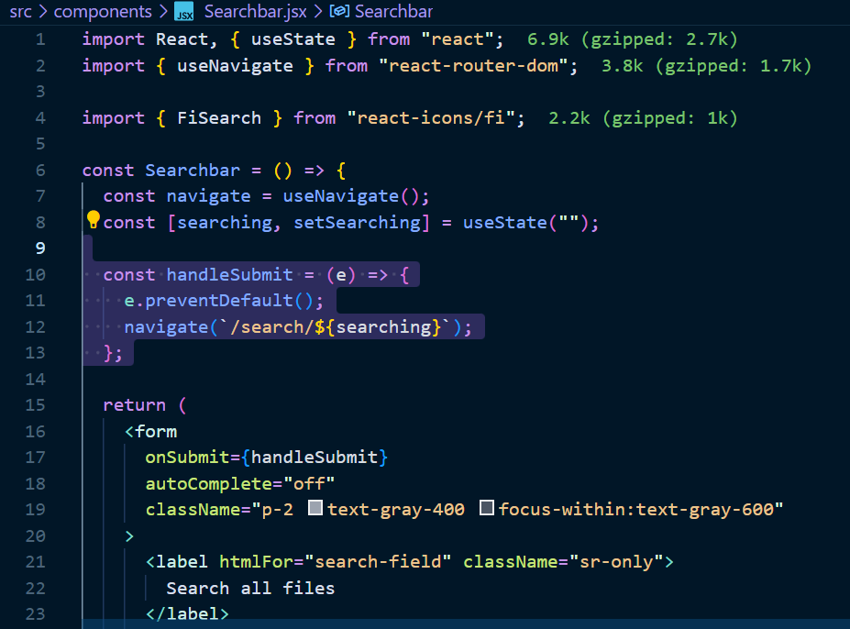

Figure : useNavigate to route page

*2nd difficulty that we tackled:*

We have a lot of constant variables, links from music genre selection or menu link, and we may reuse those constants. So, we came up with the idea, using an constant file to store those variables.

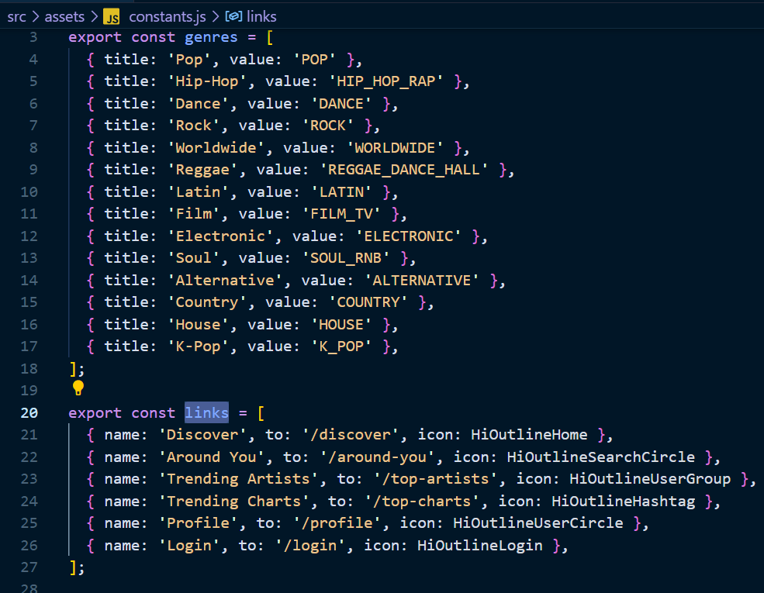

Figure : constant file

*3rd difficulty that we tackled:*

Handling react table with sorted, pagination information is not easy for the first-time using developer. We want to split sections of table such as header, row, page number to components. Each component may concentrate on its own job, making the code easier to comprehend and maintain. By dividing the table into smaller components, the code may be reused in other areas of the project. Rendering all rows at once in a huge table might cause performance concerns. We can improve speed by limiting the number of rows presented via pagination. Dividing the table into smaller components allows for greater flexibility in how it is shown and interacted with, making it easier to add features such as sorting and filtering.

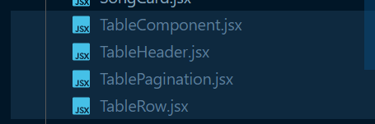

Figure : Table components

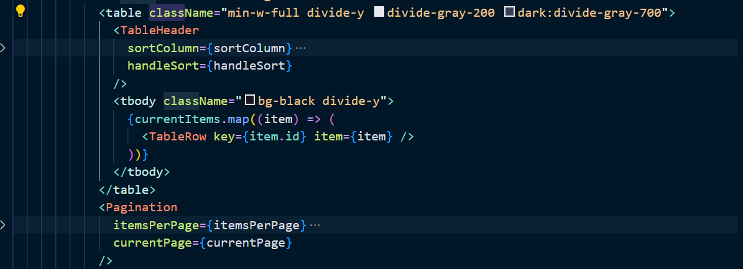

Figure : Table component usage

## Extensions (Optional)

What can be implemented in the future? We have limited timing to complete this assignment, so we only implemented important features for this app. We have list of could do features that can be implemented to improve the app:

_ User can play songs in the app.

_ User can like their songs, and those will save into user profile as their favorite playlists.

_ User can share songs by share music link with their friends.

_ User profile with their favorite songs, album, artist.

_ User can create their personal playlist.

_ Get streamline music data from app database (currently we are using faking streamline data).

## User guide

1. Using menu
2. General Menu:

By selecting different sections on the menu or mobile menu (Figure 22, Figure 24). The application will navigate you to page that suit with your selection.

1. Login Page:

Click Login section on Menu => Pop up modal for login section (Figure 31). You should input your email and password as required fields in this sign in section, then click the Sign button to login.

Or you can click to Continue as Guest to keep using the application as Guest.

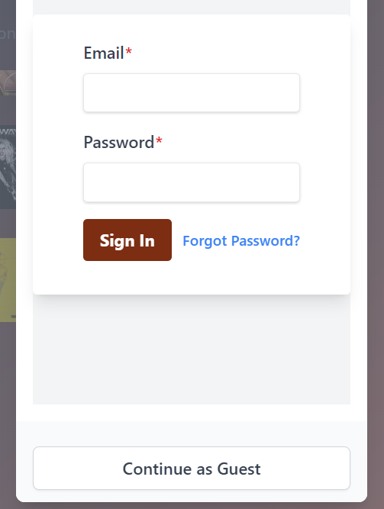

Figure : Sign in popup

1. Forget password:

Click Forgot Password link (Figure 31) => The Forgot password page will be shown to help you recover your password by sending recovery email.

1. Show song detail:

Choose any song that you want to see the song in detail (for example: we selected Flowers of Miley Cyrus (Figure 41)). The application will show the Flowers’ detail (name, artist, genre, lyric details). In addition, we also display a list of related songs that you may be interested in.

1. Show artist detail:

Choose any artist that you want to see their detail:

_ Computer user: hand icon will show up.

_ Mobile/Tablet user: select artist name.

The application will show artist information (for example: we selected David Kushner). And his information is shown as Figure.

1. Search song/artist:

On the search bar on top of the page (Figure 22). You can type the song or artist that you want to search for (Figure 44, Figure 46), then click Enter. The application will show list of songs that suits with your searching (Figure)

1. Show charts table:

In See more section (Figure 22) of Hot hits, you can see the table of list of famous charts around the world (Figure 2).

In the table, we already sorted charts by their names, you can click at arrow up (to sort as Ascending), arrow down (to sort as Descending) for both Title and Artist).

We have options for table pagination, so if you need to see more charts you can click at page number at the bottom of charts table (Figure 40).

## References

NPM, <https://www.npmjs.com/package/react-router>

NPM, <https://www.npmjs.com/package/swiper>

NPM, <https://www.npmjs.com/package/react-icons>

Shazam Core API, <https://rapidapi.com/tipsters/api/shazam-core/details>

## Appendices

#### Appendix A – self-checking against CRA

|  |  |  |
| --- | --- | --- |
| Marks | Grade level (in 1- 7 scale) my work belongs to (delete the ones not suitable) | Marks I think I should get |
| **Overall Functionality**  **(30 marks)** | 7 | 30 out of 30 |
| **Application performance**  Note: balance between client and server processing  **(10 marks)** | . 7 | 10 out of 10 |
| **Application Robustness**  **(10 marks)** | 7 | 10 out of 10 |
| **Application UI Design**  Note: this is purely based on function and usability. There is no direct assessment of the quality of the graphic design.  **(10 marks)** | 7 | 9 out of 10 |
| **Application architecture and Code Quality**  **(10 marks)** | 7 | 9 out of 10 |
|  |  |  |
| **Report and Reflections**  **(20 marks)** | 7 | 19 out of 20 |
|  |  |  |
| **Video demo**  **(10 marks)** | 7 | 10 out of 10 |
|  |  |  |
| **Overall Marks (100)** |  | 97 out of 100 |

#### Appendix B – Screenshots of test plan results



Figure 27: Home page overall with web browser menu

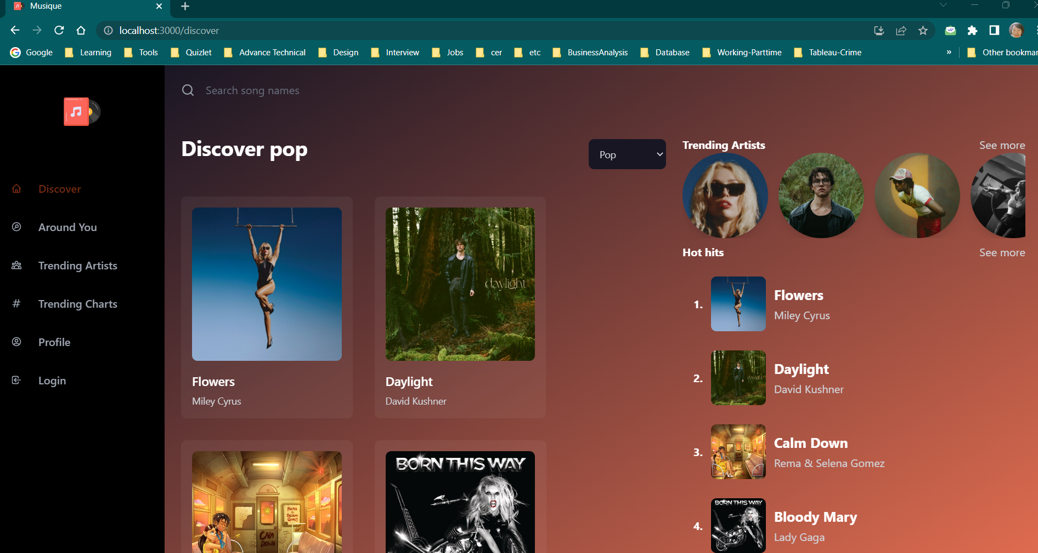

Figure 28: Discover page.

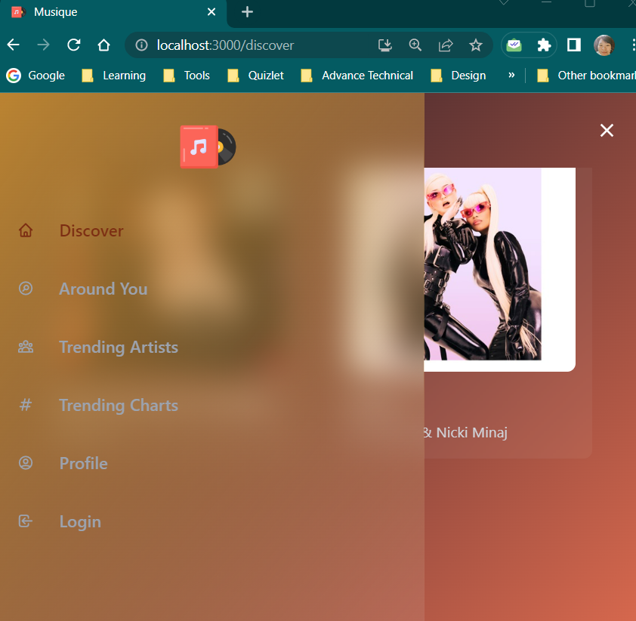

Figure 29: Mobile menu

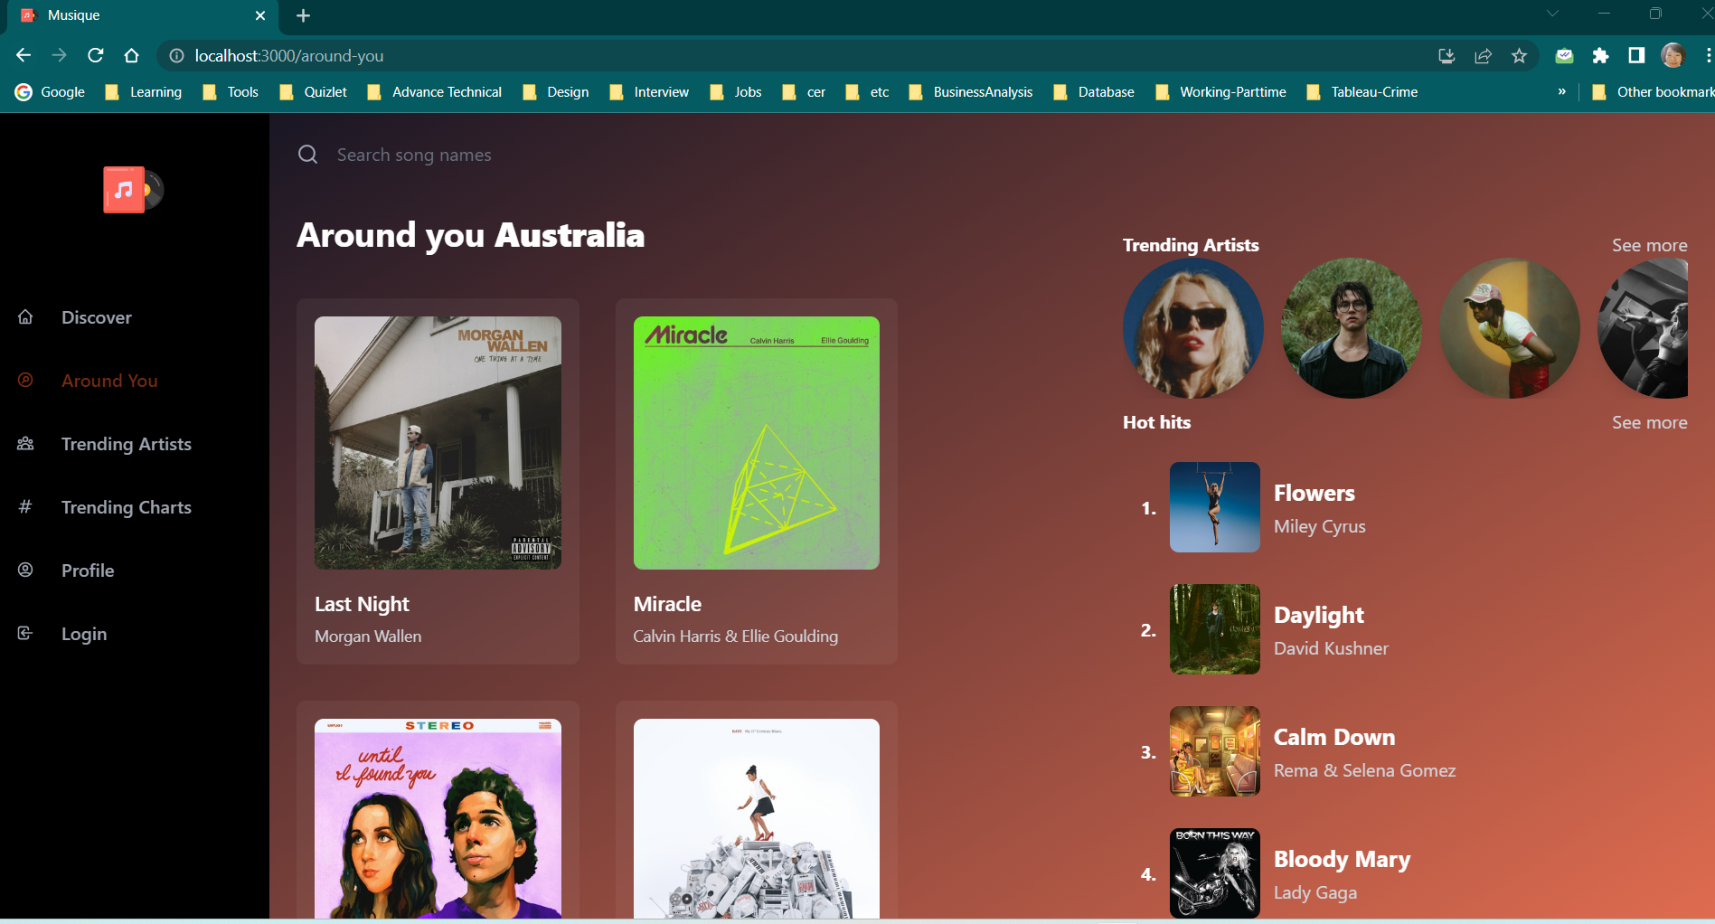

Figure 30: Around you Page

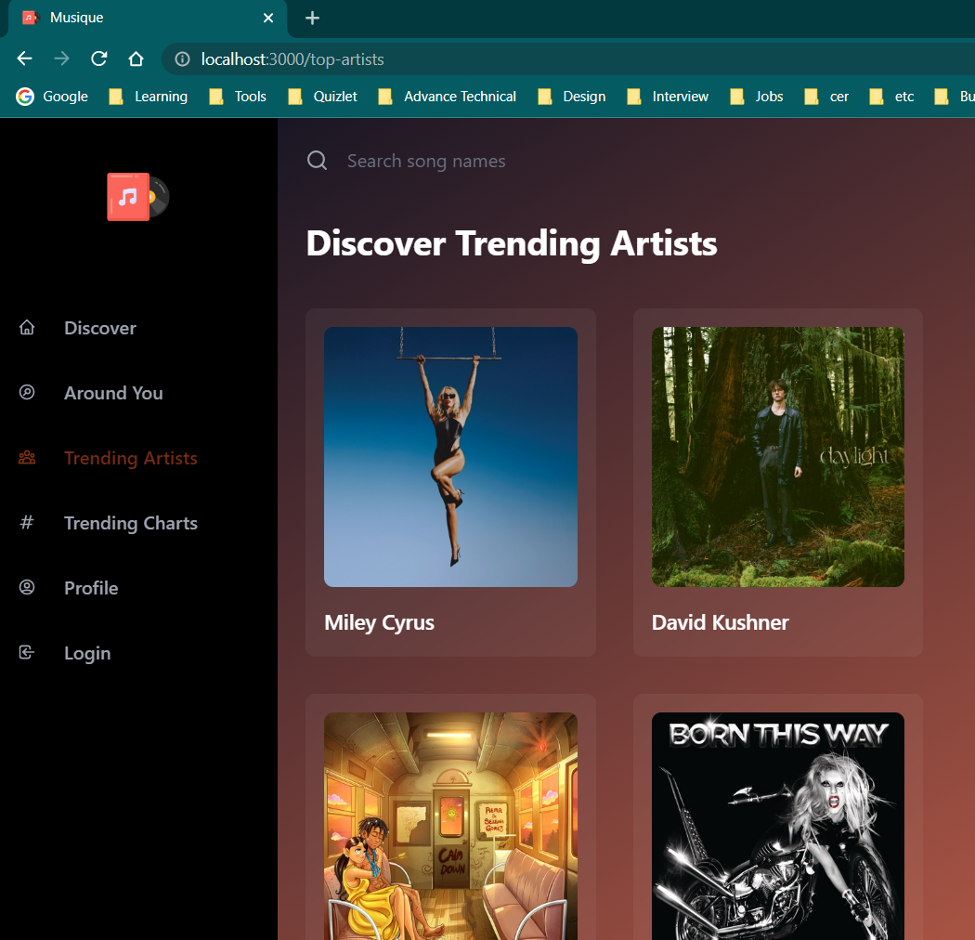

Figure 31: Trending Artist page

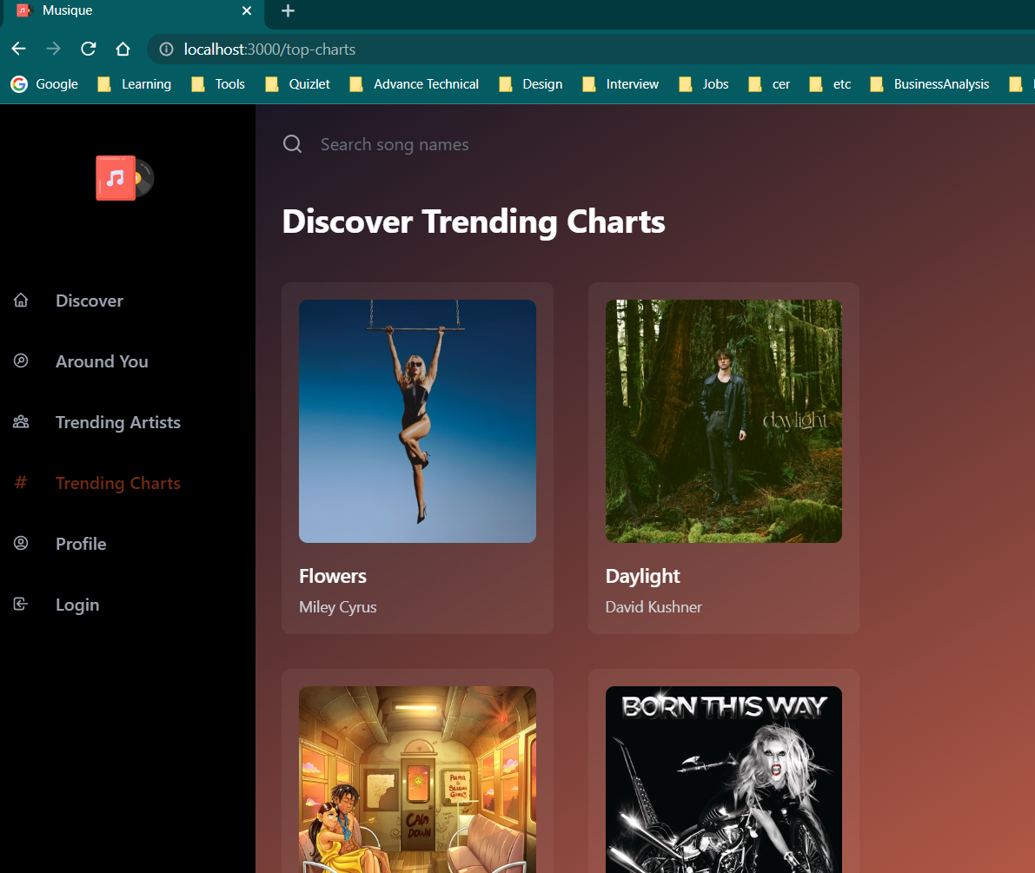

Figure 32: Trending charts page.

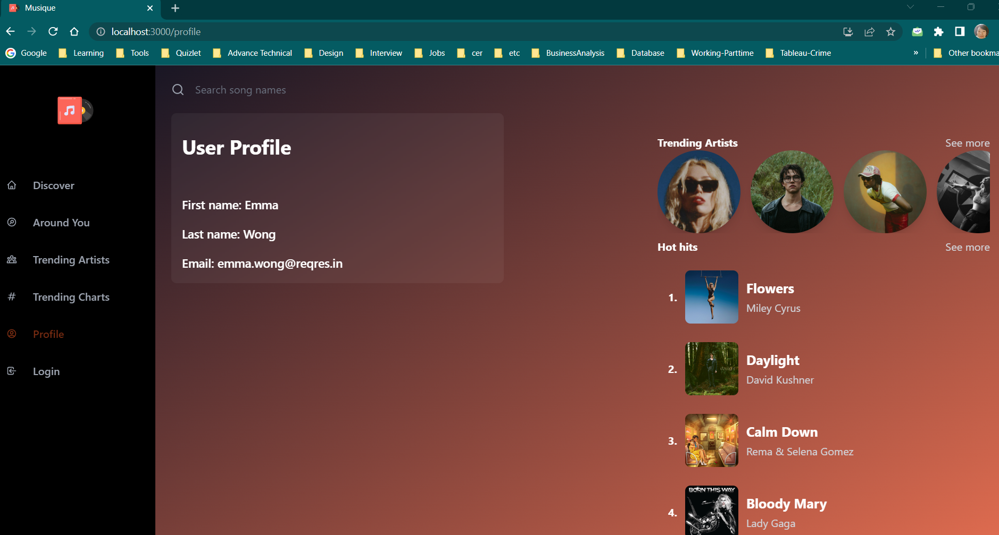

Figure 33: User profile page

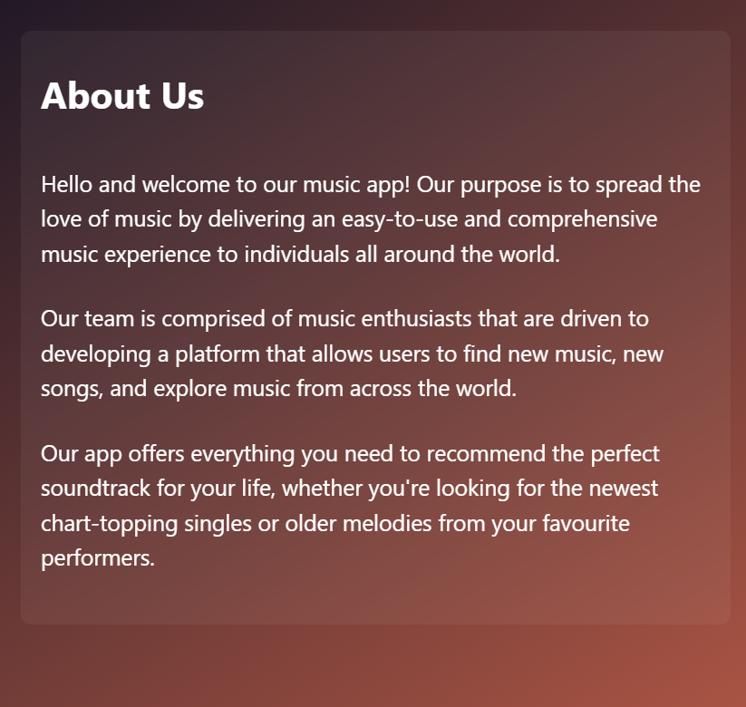

Figure 34: About us page



Figure 35: Contact us Page

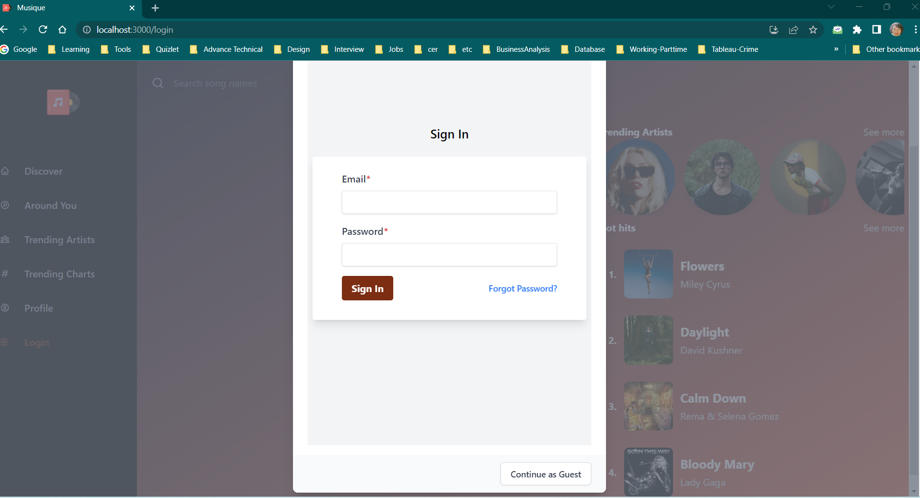

Figure 36: Sign in modal popup

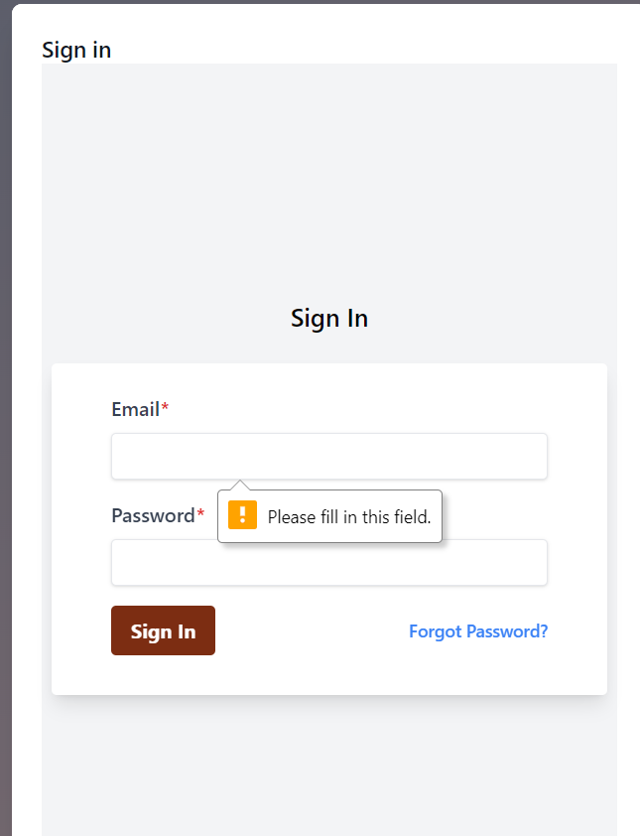

Figure 37: Sign in with required fields.

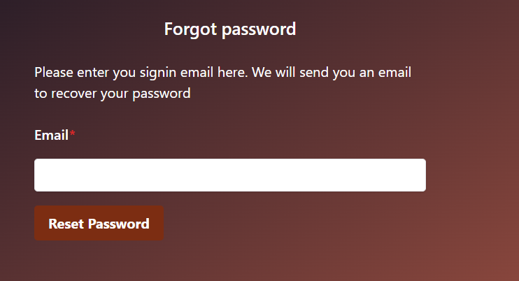

Figure 38: Forgot password page

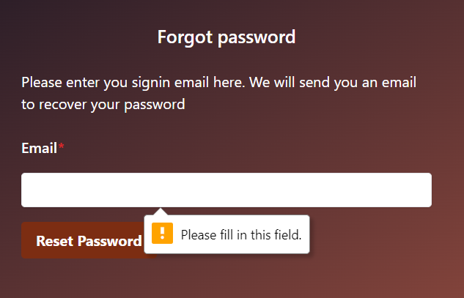

Figure 39: Forgot password required field.

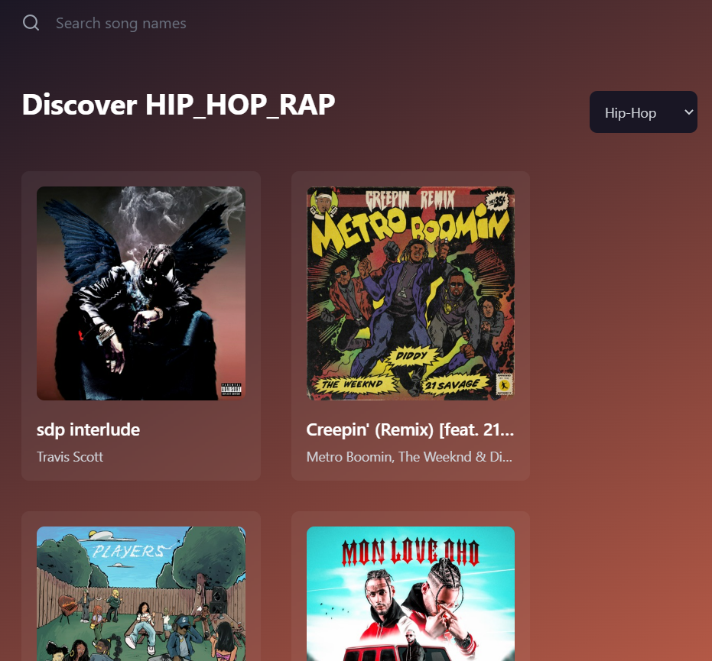

Figure 40: Filtered songs my genre.

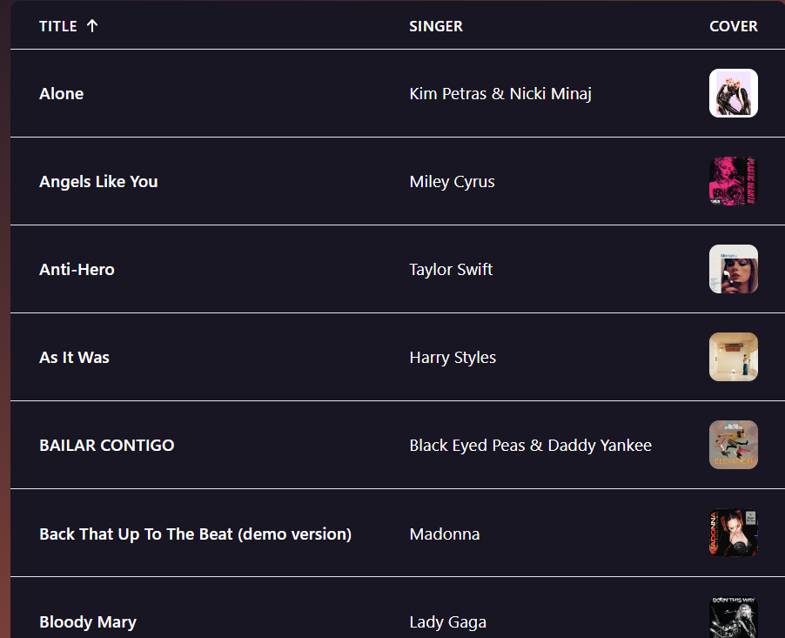

Figure 41: Top charts table with ordered

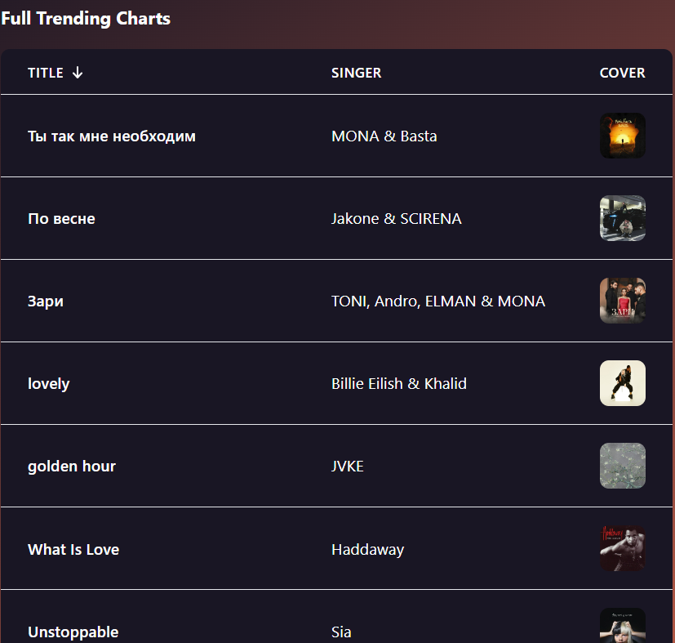

Figure 42: Filtered charts by song name (descending order)

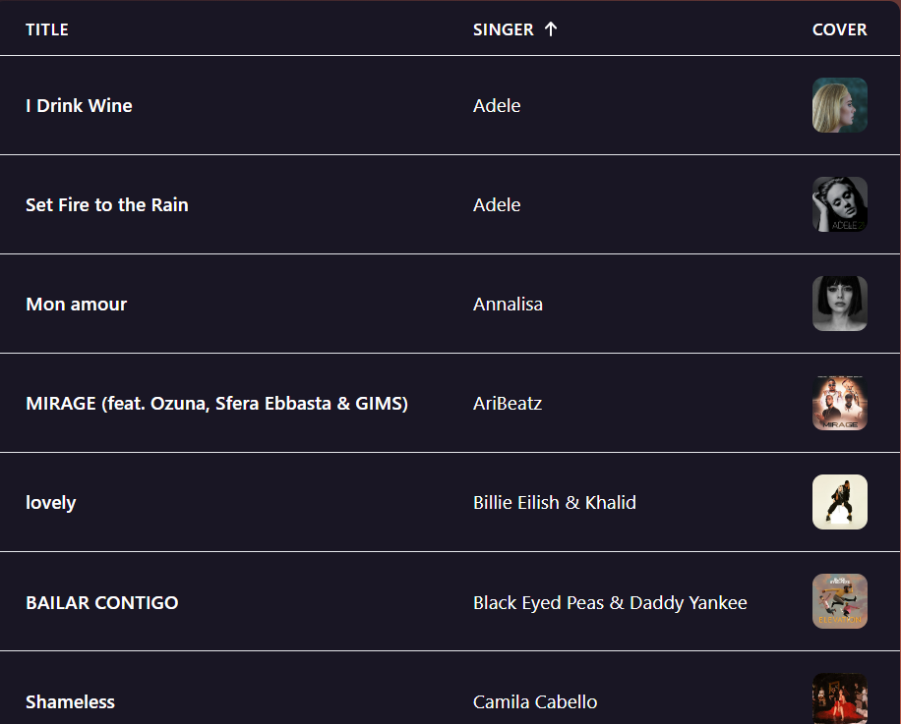

Figure 43: Filtered charts by Singer name (ascending order)

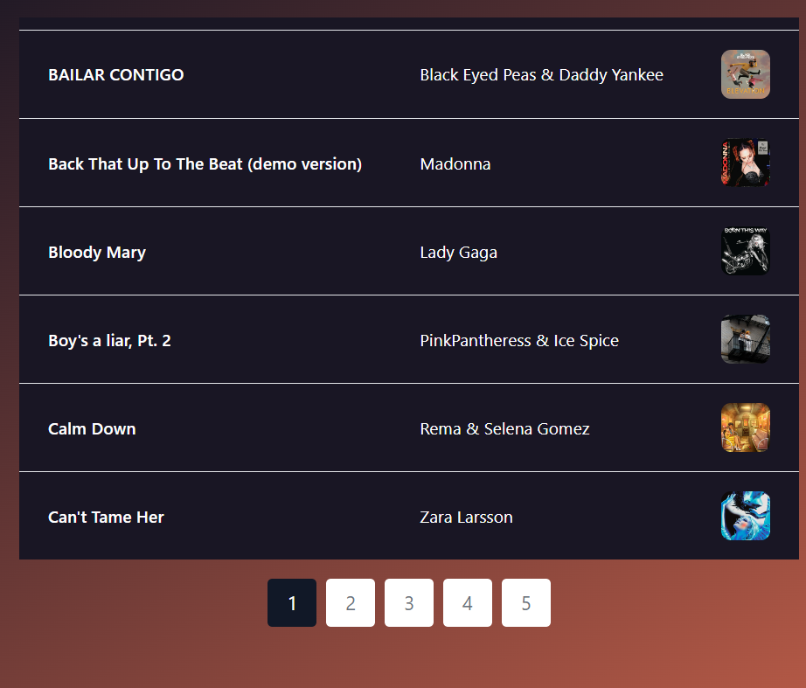

Figure 44: table with pagination

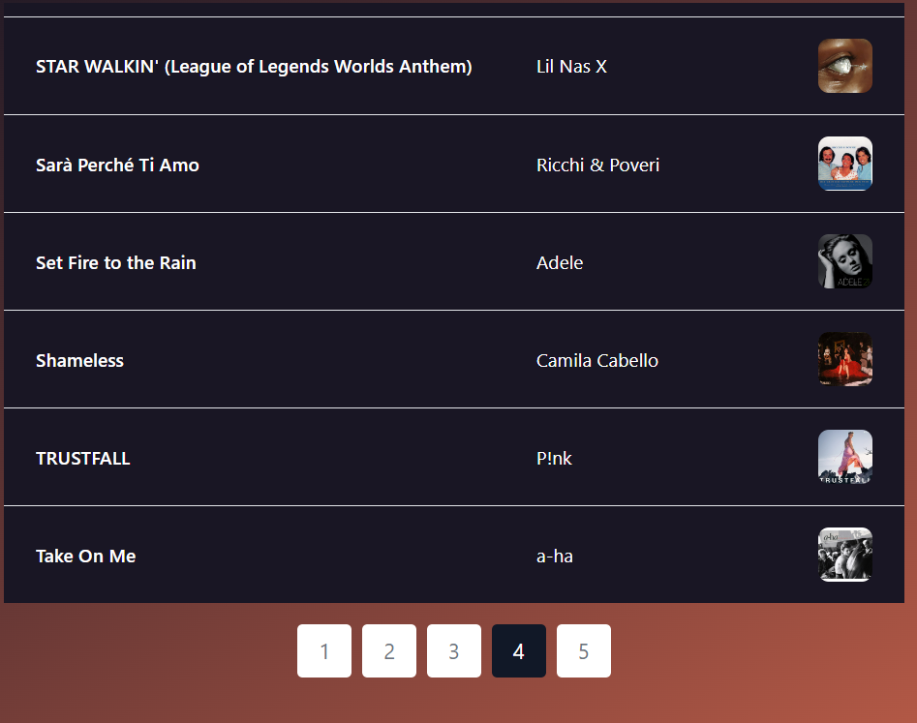

Figure 45: move to next songs by table pagination.

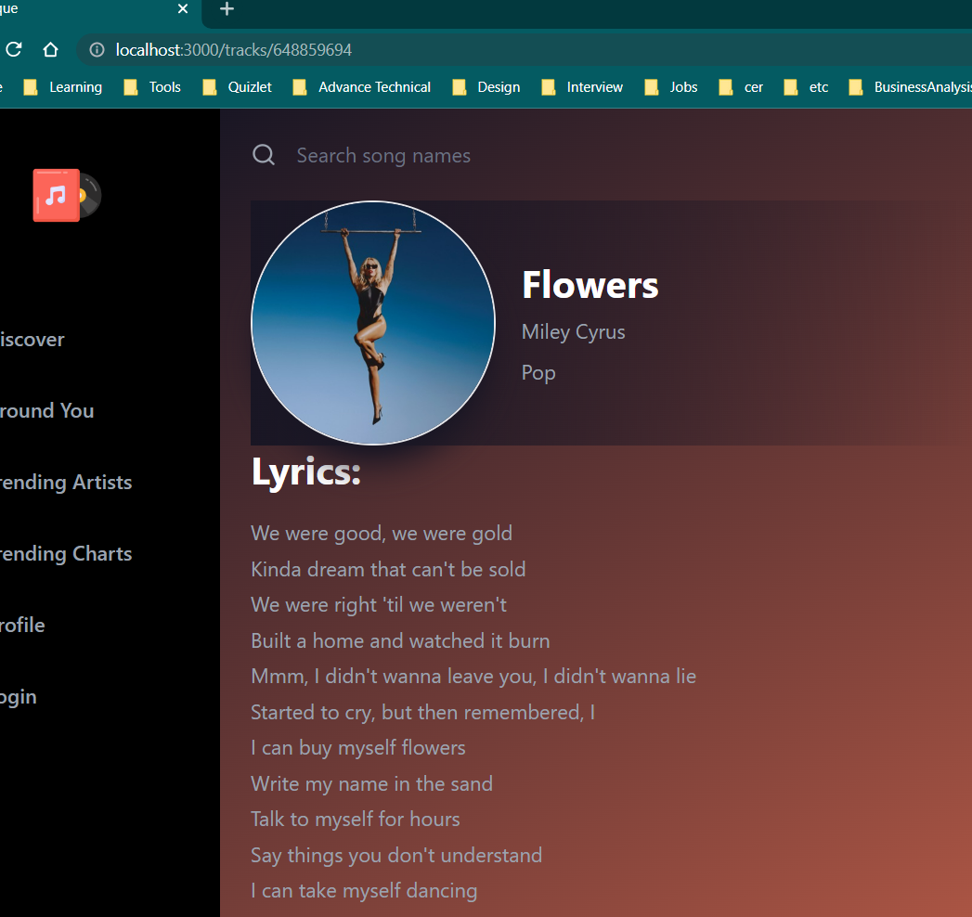

Figure 46: Song detail page

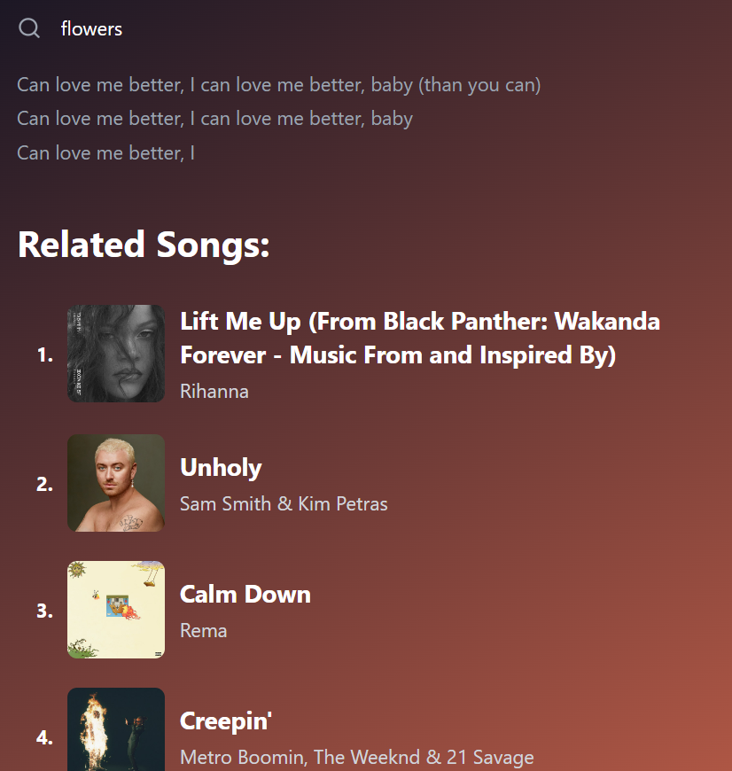

Figure 47: Suggest related songs

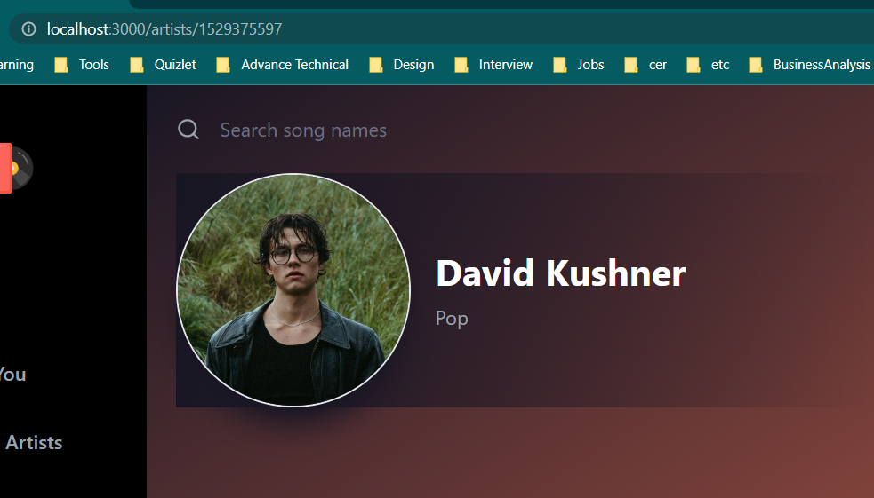

Figure 48: Artist detail page

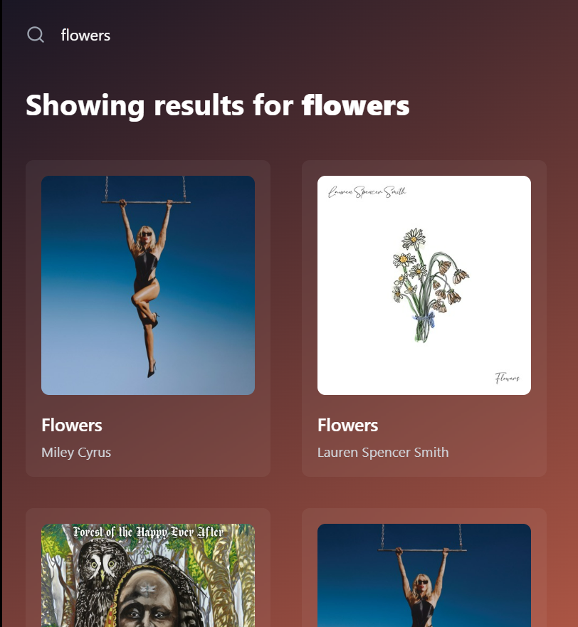

Figure 49: Search valid song name

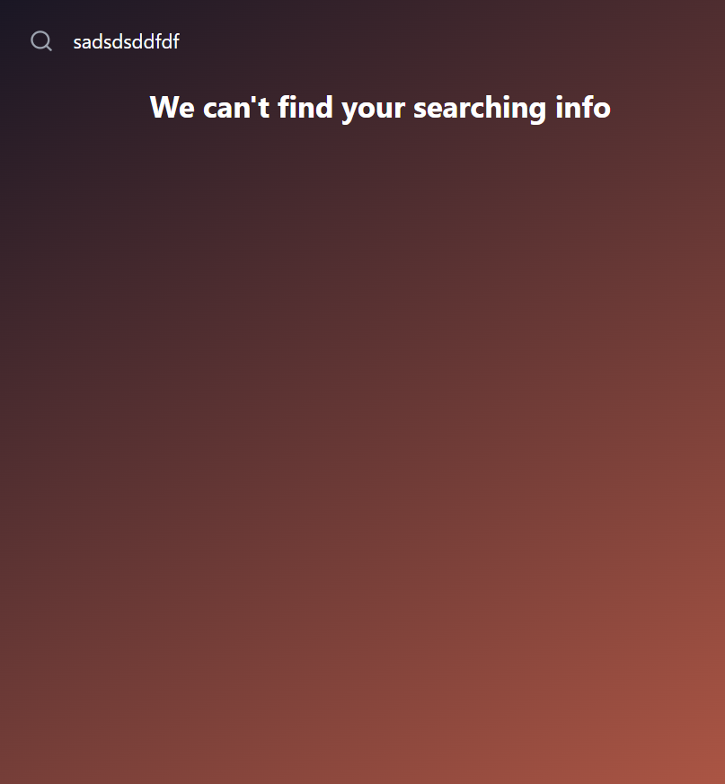

Figure 50: Search invalid song name.

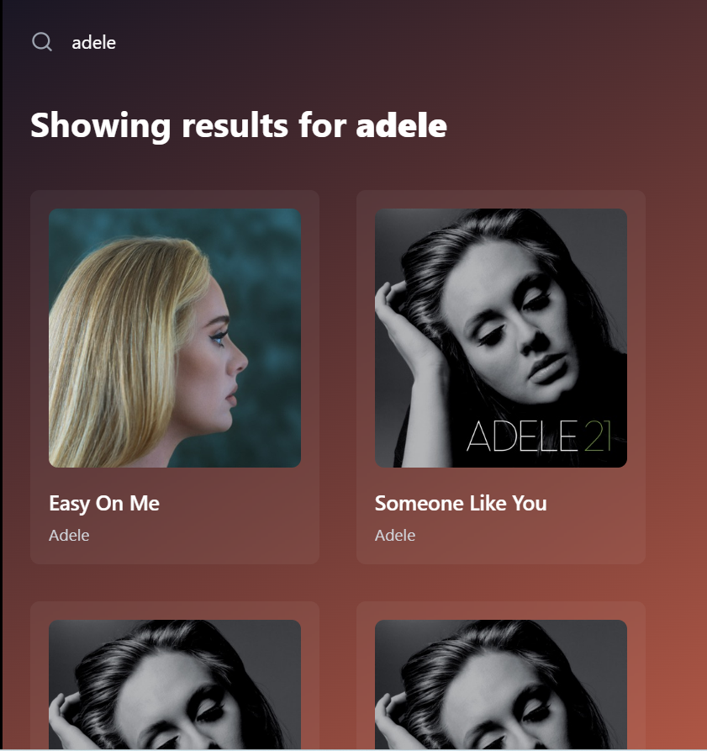

Figure 51: Search valid artist name

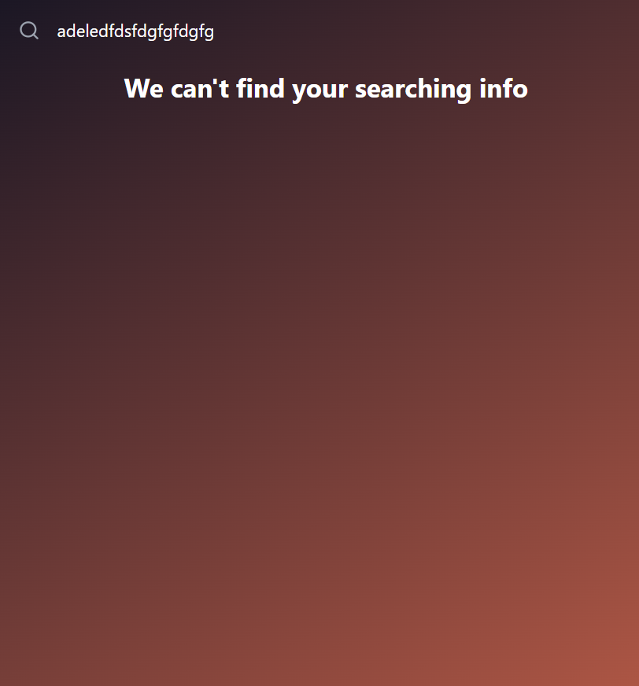

Figure 52: Search invalid artist name



Figure 53: Error page

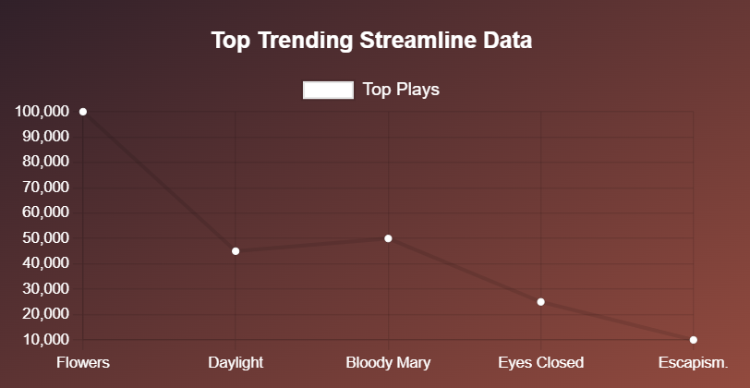

Figure 54: Top Trending Streamline data